6A^{th} Grade: Unit 14, Lesson 6

- Write an expression equivalent to 12y using the terms 12 and y only.

(12)(y); $12×y$; $12∙y$ or equivalent

- Write a multiplication equation that is represented by the Algebra Tiles shown.
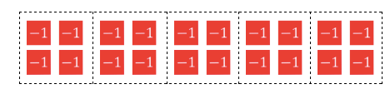

5(-4)=-20

- What is the value of 7m when m=3?

21

- Write a division equation that is represented by the bar model shown.
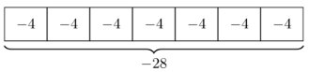

$$-28÷7=-4$$

- Write a multiplication equation that is represented by the bar model shown.
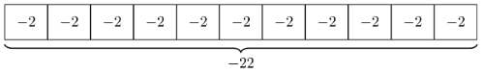

-2(11) = -22

- Write a division equation that can be used to find the value of one bar.
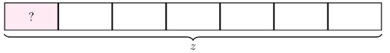

$$z÷7=?$$

